FACULTY PROFILE

I. General Information
 | Name: SHOYEB KHAN | 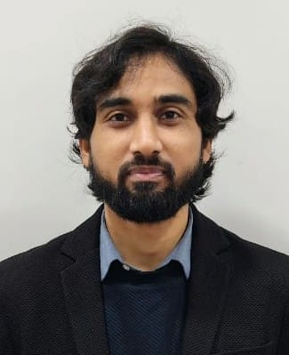
 | Address: 22/A, Q TYPE COLONY, SUNDAY BAZAR, BERMO, BOKARO, JHARKHAND, PIN-829127
 | Designation: Lecturer in Perspectives in Education
 | Date of Birth:12/04/1991

II. Academic Qualification
S.No. | Examination Passed | Year of Pass | Institution / Board | Marks obtained in individual subjects (and average)
1. | MA Sociology | 2017 | IGNOU | 63.4%
2. | B.Sc. Maths Hons. | 2013 | Kolhan University | 64.8%
3. | 12th (Science) | 2009 | CBSE | 62.8%
4. | 10th | 2007 | CBSE | 76.4%
5.

III. Professional Qualification
S.No. | Examination Passed | Year of Pass | Institution / Board | Marks obtained in individual subjects (and average)
1. | M.Ed. | 2024 | Department of Educational Studies, Jamia Millia Islamia | 81%
2. | B.Ed. | 2022 | Central Institute of Education, University of Delhi | 72%
3.
4.

IV. Seminar / Workshop / Conferences / FDPs attended

“National Symposium on Indian Knowledge System”, organised by D/o Educational Studies, Jamia Millia Islamia.

• “Discovering the Mathematics of Art: A workshop on geometric pattern in Islamic Art” organised by D/o Educational Studies, Jamia Millia Islamia in collaboration with Ohio University.

“Virtual National Workshop on Development of Learning Resources in Science and Mathematics Education” organised by the D/o Education, University of Delhi.

“H5P web tool Workshop: Unlock the power of Interactive Learning” organized by D/o Educational Studies, Jamia Millia Islamia.

“Two Day RSC professional development program for science teachers” organised by DES, JMI in collaboration with Royal Society of Chemistry

7-day workshop on “Bhartiya Bhasao me Anusandhan aur Akadmik Lekhan”, organised by D/o Educational Studies, Jamia Millia Islamia

V. Paper Presented in Seminar / Workshop / Conferences / FDPs

“Textbook Culture: An Analytical Study” -Shoyeb Khan and Areeba Hussain Presented in International Virtual Conference on Education, Sustainability and National Policies: Strategies, Bandwagon and Administrative Models-Jamia Millia Islamia and Universitas Pendidikan Indonesia (Best Presentation Award)

“Social Media Trolling and Mental Health: Womens’s Experience”- Joshua Solomon and Shoyeb Khan
Presented in Two Day National Conference on Role of Religions in Harnessing Human organized by Institute of Objective Studies in collaboration with Department of Islamic Studies, Jamia Hamdard, New Delhi.

VI. Paper Published

“Textbook Culture: An Analytical Study” -Shoyeb Khan and Areeba Hussain
Published in edited book “Education and Sustainable Development Goals: Policy Practices and Challenges” by Archers and Elevators Publishing House. (ISBN: 9788119653409)

“Academic vs Vocational Education: A Policy Analysis”- Simi Shukla, Shoyeb Khan, Sakshi, Pranjal Gupta & Digvijay Singh and Hari Nandan
Published in MERI Journal of Education, October 2021.

